## Merchant

Scoping start date: 2023

Implementation Completed Date (Go live date): January 2024

MSA Signature Date: Feb 7, 2024

GTM POC: Rebecca

ERP: QBO

Tax Integration: (in progress) Avalara migration

### 

### Key people at Merchant

### Vin Cocito - Chief Customer Officer (co-founder)

* Jared Zimmer - chief of staff

### Company summary

Inspiren provides innovative AI-powered solutions for healthcare facilities to optimize patient care and workflow efficiency.  
  
AM Notes

* They are super nice and patient
* They bill very ad hoc relative to their contracts (should probably be event-based/milestone triggers but instead they are just going to use create your own billing terms until they get more systematic in their approach)
* They just finished an Avalara implementation so we should now be picking up Avalara taxes properly (as of 3/28)

### Billing model

* Hardware + recurring subscription of varying lengths (e.g. quarterly, monthly)

### Contract Processing Steps

All payment terms are laid out nicely in each contract, with a clear section called “Billing Terms” that will define billing frequency and net payment terms for each billing term outlined. Please follow this when creating BTs.

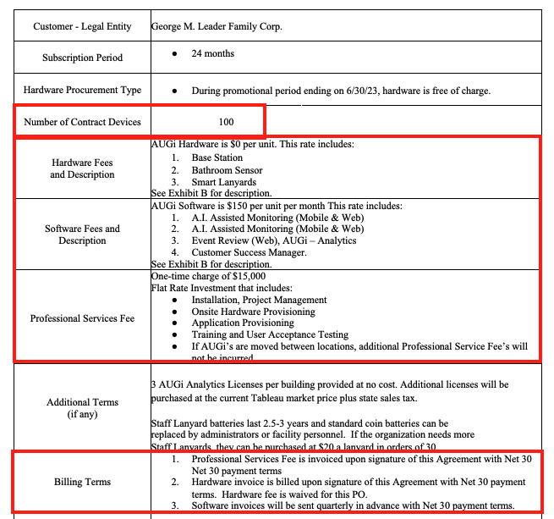

Boxed in Red is what to pay attention to, al described below:

* 3 types of fees:
  + Professional Services/Implementation
    - This is a one time fee and is usually billed up front, which will be outlined in the Billing Terms section of the contract.
    - Sometimes it is waived, or not included, so not BT needed
      * Sometimes, it says “waived if signed before a certain date” - cross reference with sign date and if signed on or before that date, no need to process
    - Integration item: Implementation Services
    - **This should always be billed to parent customer, not sub-customer**
  + Hardware
    - Process as flat price
      * Name: AUGi Hardware
      * Billing Type: Flat Price
      * Integration Item: AUGi Base Station
      * Total devices are specified in the table on the front page of the contract (above). Use this to calculate total hardware cost,
      * Hardware billed up front in most cases, so use the date specified in the Billing Terms section. If no date specified in that section, use the effective date.
        + This also applies if the hardware is billed upon shipment/installation - use effective date

However, in these cases, we *might* get amendments in the form of an email that will adjust the amount/date of this BT (still confirming this process)

* + - * + **EXCEPTION**: If there are multiple locations (sub-customers), the total hardware billed should be according to the amounts specified for the location (instructions/image of this is below)
        + **ANOTHER EXCEPTION:** UNLESS it is specified that the hardware will be **leased**, in which case follow the instructions in the Billing Terms section (often billed monthly or quarterly with software).

For lease option, the date should start on the first of the next full month if ship date or install date are not specified

In this situation, there might be language that says there is a “Lease option” - if present, process both the lease options and bill up front option, and the merchant will adjust based on which is chosen (example below).

For Hardware Lease:

Integration item: AUGi Base Station Lease

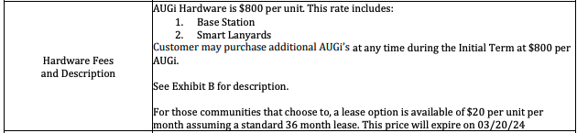

* + - If $0, no need for a hardware BT
  + Software
    - Process as usage
      * Name: AUGi Software
      * Billing Type: Unit Price
      * Event: has_active_camera
      * Integration item: AUGi Base Platform
      * **\*\*\*\*NOT IN ARREARS - please uncheck the “Is billed in arrears” checkbox for all usage BTs\*\*\*\***
    - Frequency according to Billing Terms section in contract
* Sub-customers
  + Some contracts have multiple locations that are contracted for, which will show up either at the bottom of each contract or listed in the order form at the top of the contract. If this is the case, each of these locations needs to be created as a sub-customer with the same BTs.
  + Example shown in the chart below, each of the Communities should be a sub-customer:

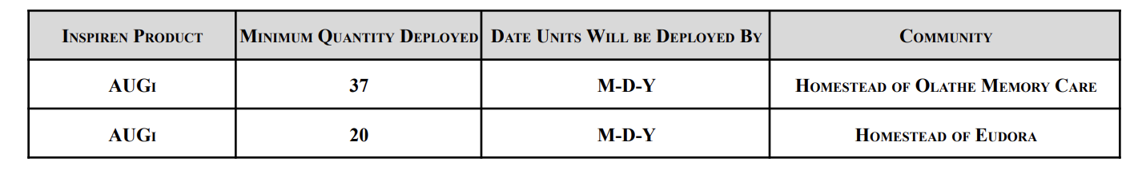

* + If the Location says TBD, then do not create at sub-customer
  + For all sub-customers, billing address should be the address on the contract.
    - Same as shipping address can be checked until we are provided with other shipping addresses later on (per below bullet point)
  + Locations are sometimes not determined upon signing the contract, or are added during a contract term, so the merchant will sometimes send over a list of sub-customers that need to be created for a contract.
    - They will send over location name (sub-customer name), address, and billing contact information
    - These should be set up with the original contract for the parent customer
    - These should only have the software BT on them (unless otherwise specified)
* Sometimes, there is more than 1 order form for a contract (order form being the table shown above. This is often because there might be different sub-customers listed or different start dates for each order form. In this case, process per normal requirements:
  + Pull out terms from both contracts
  + Implementation - process under parent customer
  + Hardware - if the amounts for the sub-customers are not listed, process under the parent customer. If amounts for each sub-customer are determined, hardware can be on sub-customers (unless otherwise specified)
  + Software usage BTs on sub-customers. If no sub-customers are specified yet, then process software only on parent customer and add later when sub-customer (location) list is received
* **Customer specifics:**
  + All Arrow recurring BTs (usage or hardware lease) need to bill on the 16th of the month
* Anything to ignore?
  + Yes - each contract will have a number of devices that is specified both at the top of the contract in the “Number of Contract Devices” section (image above). **If there are multiple locations/sub-customers**, then ignore this and use the instructions above for hardware.
* Default Service Term
  + If None Listed, Ops Default is 1 Year
* Default Net Payment Terms
  + If None, Default to Net 30
* Default Billing Frequency
  + If None Listed, Ops Default is Monthly
* How do we handle taxes as a line item?
  + If None Listed, Ops Default is every tax line item becomes a BT

### Events Processing (if necessary)

* Detailed above

### Integration Items

* Software usage BT: AUGi Base Platform
* Hardware: AUGi Base Station
* Hardware Lease: AUGi Base Station Lease
* Professional Services: Implementation Services

### Customer Information

### Feature Requests

* Support for a QBO bundle item (they do this for HW + SW)
* Reporting by community (sub customer)

### Rewatch Calls

* Last call: <https://tabs.rewatch.com/video/34e3eioqk4vmdz2n-inspiren-tabs-march-28-2024>
* Earlier set up call:

<https://tabs.rewatch.com/video/qyga58ryi69vxx5z-inspiren-tabs-january-11-2024>

| Arrow Senior Living - Mentor | 8180 Mentor Hills Dr, Mentor, OH 44060 | homeofficeaccounting@arrowseniorliving.com |
| --- | --- | --- |
| Arrow Senior Living - Summit | 16100 Chenal Valley Dr, Little Rock, AR 72223 | homeofficeaccounting@arrowseniorliving.com |
| Arrow Senior Living - Highland Heights | 305 Bishop Rd, Highland Heights, OH 44143 | homeofficeaccounting@arrowseniorliving.com |
| Arrow Senior Living - Boulevard St. Peters | 500 Bluffstone Circle, St Peters, MO 63304 | homeofficeaccounting@arrowseniorliving.com |
| Arrow Senior Living - Rushwood | 2121 N 143rd Street E. Wichita, KS 67230 | homeofficeaccounting@arrowseniorliving.com |
| Arrow Senior Living - Crestone | 21810 W 119th Street Olathe, KS 66061 | homeofficeaccounting@arrowseniorliving.com |
| Arrow Senior Living - University Living | 2865 South Main Street Ann Arbor, MI 48103 | homeofficeaccounting@arrowseniorliving.com |
| Arrow Senior Living - Boulevard St Charles | 3330 Ehlmann Road St. Charles, MO 63301 | homeofficeaccounting@arrowseniorliving.com |
| Arrow Senior Living - Boulevard Wentzville | 110 Perry Cate Boulevard Wentzville, MO 63385 | homeofficeaccounting@arrowseniorliving.com |
| Country Meadows - Forks | Country Meadows 175 Newlins Rd W #1 Easton, PA 18040 | AccountsPayable@countrymeadows.com |
| Country Meadows - York | Country Meadows 1920 Trolley Rd York, PA 17408 | AccountsPayable@countrymeadows.com |